Intermountain West Data Warehouse (IWDW)

Phase 1 Status Report



 

1. **Overview**
2. **IWDW Website**
   1. Public Face (about pages, Project level documents);
   2. Data (modeling platform data, emissions tools, model performance evaluation (MPE) tools, source apportionment tools, monitoring data tools);
      1. Bulk Data
      2. Emissions data tools
      3. Modeling data tools
      4. Monitoring data tools
      5. Metadata tools
   3. Resources (modeling platform data inventory, description, modeling protocol and MPE documents, meetings, OC and GB secured space, user management, Project documentation, forum, wiki);
      1. Modeling data
      2. Reference documentation
      3. Community and support
      4. Warehouse operations and management
   4. Administration (user account management (roles), modeling data inventory (platform metadata) and tracking (data request status, automated emails), IWDW project management).
3. **Operations**
   1. Data transfer (incoming from WAQS data providers, and servicing of outgoing data requests to users);
   2. Data processing (data ingest and transformation tasks to align incoming datasets to IWDW database architecture);
   3. Project management (Workgroup and committee meetings)
   4. Dependencies (Project in-kind support from other software development projects and external modeling activities)
4. **Computer Hardware, Code Base, and Data Storage**
   1. File server
   2. Databases
   3. Backup and recovery
5. **Preliminary work plan for IWDW Phase 2**
   1. Un-deployed resources and “loose ends” from IWDW Phase 1
   2. Software development goals
   3. Integration with WAQS Phase 3 Modeling
   4. Incorporate external modeling studies
   5. Other outcomes (track publications using IWDW supported modeling platforms)
   6. Monitoring Network Assessment
6. **IWDW Overview**

The Intermountain West Data Warehouse - Western Air Quality Study (IWDW-WAQS) is a joint data warehouse and regional air quality modeling project. The IWDW-WAQS serves the air quality planning needs of the Project’s Cooperating Agencies. Project background and scope are available on the [IWDW website](http://views.cira.colostate.edu/tsdw/About/Default.aspx). This report describes IWDW outcomes over the two year period from October 1, 2014 to September 31, 2016, or IWDW Phase 1[1]. Outcomes of the Project’s air quality modeling effort are described in various WAQS reports hosted on the IWDW [document](http://views.cira.colostate.edu/tsdw/Documents/) archive. IWDW outcomes described in this report focus on the IWDW website, database development, and data and project management.

The Data Warehouse is a repository of air quality data related to ambient monitoring data, emission inventories, meteorology, air quality modeling inputs and output, and evaluation and visualization tools. The data stored in the IWDW are available for use to the Cooperators and public for air quality projects.

The IWDW Team work closely with Project Cooperators to set IWDW work priorities, ensure completeness and integrity of modeling platform data, track development milestones, and develop data visualization and analysis tools that will aid IWDW users. This collaborative development approach ensures that IWDW data and resources meet the needs of a range of agencies and groups performing air quality modeling.  Logos from Project Cooperating State and Federal Agencies are shown on the Report’s cover page.

The IWDW development team is based at the Cooperative Institute for Research in the Atmosphere (CIRA), a federal research institute affiliated with Colorado State University. The computers that host the IWDW website, wiki, ftp file server, and databases are housed at CIRA. Project coordination is provided by The Western States Air Resources Council (WESTAR). Meteorology, emissions, and air quality modeling data are provided by The University of North Carolina Institute for the Environment (UNC-IE) and Ramboll-Environ. Logos for these groups are shown on the Report’s cover page.

1. **IWDW Website**

Figure 2.1 shows resources (e.g. webpages, tools and other computer infrastructure) that make up the IWDW. The bulk of IWDW development was performed by CIRA staff during IWDW Phase 1. In some cases, resources were leveraged from other projects (see *Leveraged Resources*, Figure 2.1, and *Dependencies,* Section 3.4.)

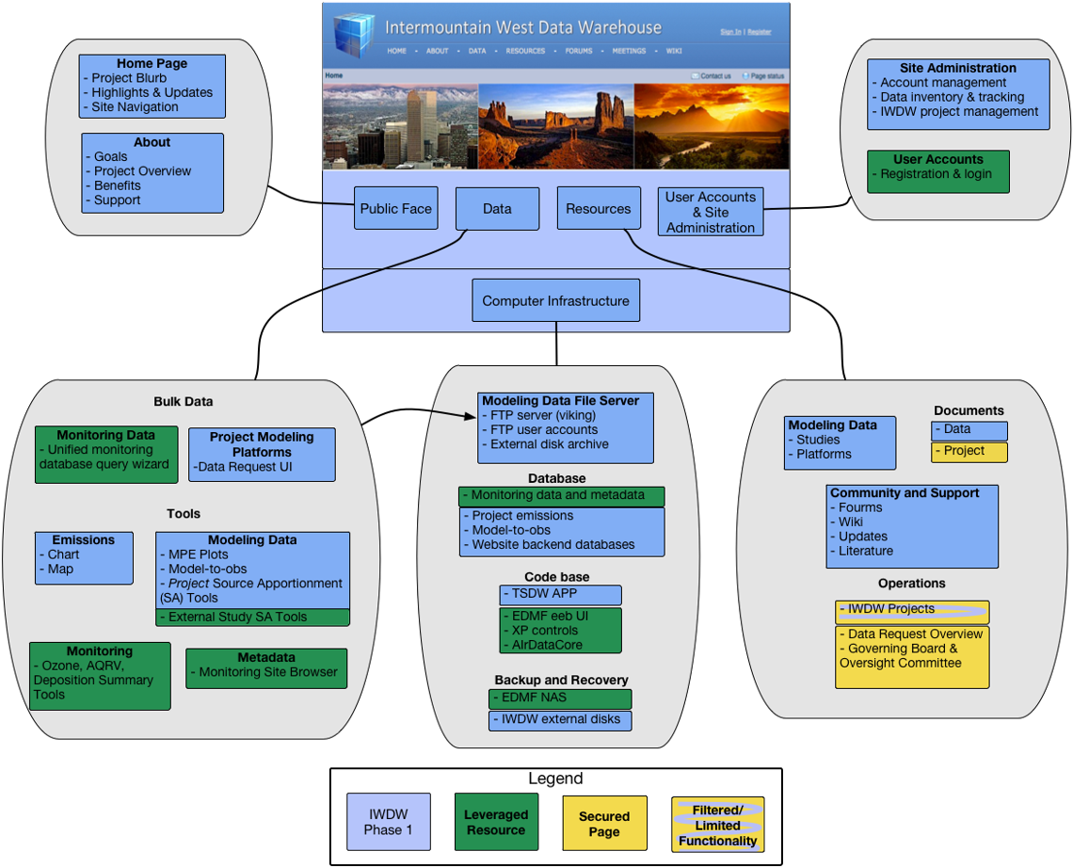

**Figure 2.1.** Schematic depicting the four main content sections of the IWDW website: Public Face, Data, Resources, and Administration. Balloons connected to each section show the content and various sub pages. The Computer Infrastructure box depicts the back-end components of the IWDW, such as the FTP file server that stores Project modeling platform data, databases that provide source data for IWDW online tools, code and backup systems. Color coding distinguishes IWDW developed components (blue), those leveraged from other projects (green), and yellow shows areas of the website that have restricted access (all of which are IWDW developed).

* 1. Public Face

The IWDW Home and About pages contain Project overview and background information. The content is written at a level suitable for individuals who may not be familiar with the Project. The “Public Face” pages include “outreach” materials that describe potential benefits to groups that may want to utilize IWDW tools and WAQS modeling platforms for their own air quality modeling activities.

The [IWDW Home](http://views.cira.colostate.edu/tsdw/) page contains a high level project overview, highlights of recent IWDW and WAQS activities, presented in a user friendly layout with easily identifiable links to Project documentation, data access pages, and other resources described below.

The main [About](http://views.cira.colostate.edu/tsdw/About/) page contains general Project information and list of Project Cooperating Agencies. Sub-pages in the About Section include *Goals, Overview, Benefits and Support*. The [Goals](http://views.cira.colostate.edu/tsdw/About/Goals.aspx) page aligns Project activities with needs of Cooperators for air quality planning. The Overview link points to two pages; [WAQS Structure](http://views.cira.colostate.edu/tsdw/About/WAQSstructure.aspx), which provides details about Project governance, such as roles and responsibilities of various Boards and Committees that oversee Project activities and funding, and [IWDW Structure](http://views.cira.colostate.edu/tsdw/About/IWDWstructure.aspx), which details the IWDW website and operations - essentially a high level and up-to-date version of this report. Rounding out the “Public Face” content are the [Benefits](http://views.cira.colostate.edu/tsdw/About/Benefits.aspx) page, which contains outreach material; and [Support](http://views.cira.colostate.edu/tsdw/About/Support.aspx) page, which describes Project funding and internal participants.

* 1. Data

The IWDW [Data](http://views.cira.colostate.edu/tsdw/Data/Default.aspx) landing page lists data access and analysis tools contained in the IWDW, including WAQS modeling platform and ambient monitoring data. The Data page separates data access tools into categories for Bulk data and tools for emissions data, modeling data, monitoring and metadata. At the completion of IWDW Phase I, the IWDW Data page provided access only to 3SAQS/WAQS modeling data, while providing access to the full suite of data from ambient monitoring networks. In the future, data from modeling studies external to the WAQS may be included in the IWDW (see *Dependencies*, Sec. 3.4).

* + 1. *Bulk Data*

The [Data Request](http://views.cira.colostate.edu/tsdw/DataRequest/Default.aspx?) form is the primary access point where users submit requests for modeling platform data. This page is intended for air quality modelers who plan to utilize WAQS modeling platforms in their entirety, or who may wish to “pick and choose” components of a modeling platform for their air quality modeling needs. The modeling platforms are intended to provide full support for CAMx and CAMQ AQ modeling studied. Studies using other dispersion models (e.g. AERMOD or CALPUFF) could utilize emissions and meteorology data sets provided by the IWDW.

Developing the data request from and backend software and database infrastructure represents a significant Phase I IWDW development effort. The data request and related web pages are used to manage requests for modeling data files hosted by the IWDW. This infrastructure includes file servers and databases (see *File Servers* and *Databases*, Sections 3.a,b); an automated email system to facilitate communications with requestors of data, the IWDW Team, and project sponsors; project management pages; and a data category and files system management infrastructure). Details on the data request lifecycle and IWDW inventory tracking can be found on the IWDW [Data Request Procedure](http://vibe.cira.colostate.edu/wiki/wiki/1017) wiki.

The [Database Query Wizard](http://views.cira.colostate.edu/tsdw/DataWizard/) allows users to download ambient monitoring data and related metadata from the FED integrated database. This tool is leveraged from the FED project (see *Dependencies*, Section 3.4). The tool includes ambient data from standard monitoring networks, such as AQS, CASTNet, IMPROVE and NADP. Such data are routinely used for MPE and air quality planning, for example to calculate monitoring site specific design values.

See A.3 for development notes from Phase 1.

* + 1. *Emissions Data Tools*

The Emissions Data Tools allow users to browse WAQS emissions data using charts and map displays. The emissions data displayed by the tools are based on WASW emission inventories, or *inputs* (sometimes referred to as SMOKE inputs) provided with WAQS modeling platforms. However, some SMOKE processing is applied to ERT tools to homogenize the data to annual totals at the state and county levels (see *Data Processing,* Section 3.2).

The emissions tools are particularly useful to compare emissions for a particular pollutant or source category across states or counties. Side-by-side comparisons between modeling scenarios, such as WAQS base case and future case scenarios, are not available in the current tool version, however such comparisons can be made by using separate instances of the Tool (that is, by opening the tool in two separate browser windows).

There are plans to allow users to upload emissions from their own modeling studies in future versions of the emissions tools (see *Software Development Goals,* Section 5.2).

Emissions Review Charting Tool: This tool displays stacked bar charts of emission data for 3SAQS/WAQS base and future case modeling scenarios. In the default view, emissions for a single scenario for all States are shown in tons/year for a single pollutant, with emissions source category “group” contributions making up segments of each bar. Source categories and States can be added/removed in an ad hoc manner, allowing comparison of various types of emissions across States. If a single State is selected, similar comparisons can be made across Counties. The tool generates a separate chart for each pollutant. If an individual county is selected, emissions are displayed by SCC in a sortable table. **Figure 2.2** is an example of the Emissions Charting Tool display.

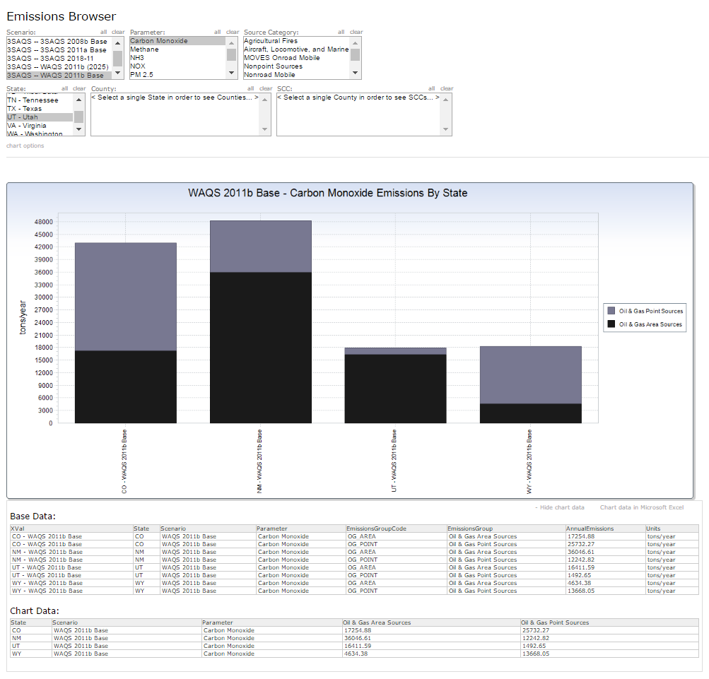

**Figure 2.2.** Emissions Review Charting Tool display showing annual CO emissions from two source categories (O&G area sources in black, and O&G point sources in grey) for four states (Colorado, Utah, Wyoming and New Mexico).

Data used to create the displays can be displayed in a table (which can also be downloaded in MS Excel format). Future versions of the emissions charting tool will allow for comparisons between modeling scenarios on the same chart. This type of generic comparison was difficult to achieve programmatically, due to the fact that various modeling platforms often contained different source categories, however such comparisons should be somewhat easier to implement in a dynamic tool for respective base year and planning scenarios.

|  |  |  |
| --- | --- | --- |
| Scenario | Parameters | Source Category (Sector) Groups |
| 3SAQS 2008b Base | 8 | 17 |
| 3SAQS 2008 Future (2020) | 8 | 11 |
| 3SAQS 2011a Base | 8 | 14 |
| 3SAQS 2011a Future (2018) | 0 | 0 |
| WAQS 2011b Base | 8 | 16 |
| WAQS 2011b Future (2025) | 8 | 16 |

**Table 2.1.** The number of parameters (pollutants) and emissions Source Category Groups displayed in the Emissions Review Tool. Statistics were obtained by manipulating the UI in the Chart version of the ERT.

|  |  |  |
| --- | --- | --- |
| **Modeling Scenario** | **Emissions Sectors** | **State/County records** |
| 3SAQS 2008b (2020) | 18 | 887491 |
| 3SAQS 2008b Base | 25 | 1010448 |
| 3SAQS 2011a Base | 26 | 978031 |
| WAQS 2011b (2025) | 20 | 660689 |
| WAQS 2011b Base | 20 | 690957 |
| **Total** |  | **4227616** |

|  |  |  |
| --- | --- | --- |
| **Modeling Scenario** | **Emissions Sectors** | **State/County/SCC records** |
| 3SAQS 2008b (2020) | 18 | 42325812 |
| 3SAQS 2008b Base | 18 | 33021294 |
| 3SAQS 2011a Base | 23 | 36636480 |
| WAQS 2011b (2025) | 14 | 24098873 |
| WAQS 2011b Base | 15 | 24206756 |
| **Total** |  | **160289215** |

**Table 2.2.** Emissions groups and total record counts for Emissions Review Tool data source tables. Using 2011b as an example, the State/County data include five emissions groups that are not present in the State/County/SCC level data (Ag fires, Wild Fires, Rx Fires, wind blown dust, and MOVES Onroad Mobile) because these emissions groups do not include SCC information. The 2011b Base Case includes one emissions group at the State/County/SCC level that is not included in the Future case (Point sources w/o CEMs), and neither the 2011b Base nor Future case scenarios include biogenics (that is, in the emissions data processed for the ERT). Statistics were obtained via data base queries (see IWDW Phase I Status.xls for query output) in the IWDW Phase I wiki.

See development notes, A.3.

[Emissions Review Mapp](http://localhost/TSDWAPP/Maps/EmissionsMap.aspx)ing Tool: The emissions mapping tool relies on the same emission data as the Charting Tool, and provides similar data selection functionality in that users can make ad hoc selections of modeling scenarios, pollutants and source category groups. The tool adds functionality that allows users to select State and Counties from a map to modify the displays. The map displays county level annual emissions totals, which auto scales to the range of values in the selection. The Tool includes pie charts that show the breakdown of emissions totals by emissions sector and, if looking at State totals, adds another pie chart to show the emissions breakdown by county. The Tool allows users to download image files of the graphical displays.

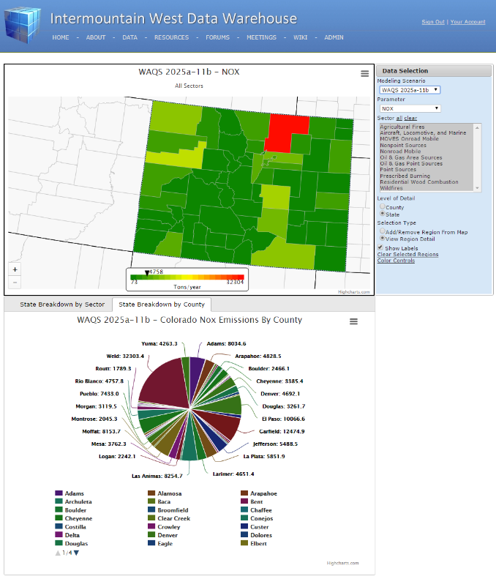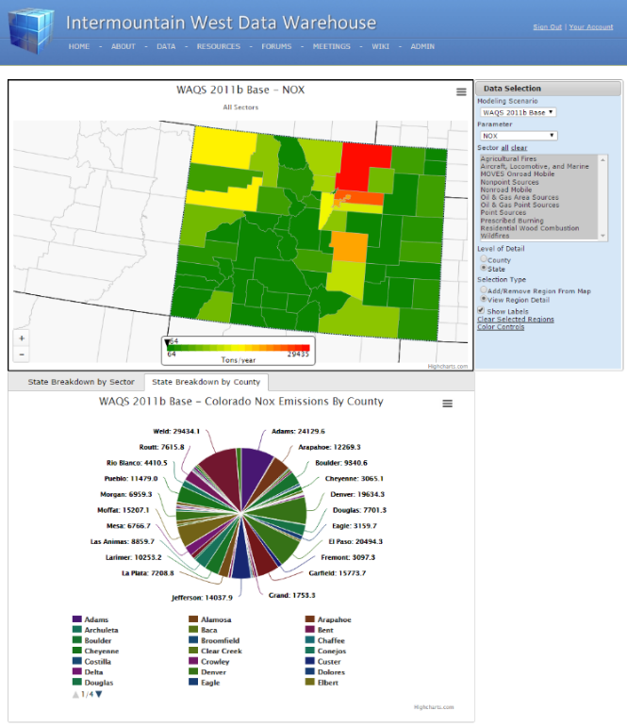

**Figure 2.3.** Displays from the Emissions mapping tool.

* + 1. *Modeling Data Tools*

Model Performance Evaluation Plots: This tool displays “static plots” generated as part of the 3SAQS/WAQS modeling MPE process. At the conclusion of Phase I of the IWDW, the tool provided access to 66,430 images.

The MPE products generally fall into three categories. Comparisons of AQ model output to observations; to other modeling simulations, and by evaluating patterns, generally via spatial “tile” plots, in model output. The Tool includes graphs and maps that compare base and future year modeling platforms, and modeling scenarios sensitivity studies, to observations from standard monitoring networks such as AQS, IMPROVE, CASTNet, etc. In some cases, comparisons to observations from special studies and/or IWDW-WAQS Project sponsored monitoring data are included. Other MPE products show model output only, for example tile plots AQ model output, or meteorological fields in the case of meteorology sensitivity studies. Plot types include tile plots, time series, bar, soccer, scatter plots, box plots, q-q plots, etc. Spatial groupings are typically by individual monitoring site, State, 4km, 12km or 26km modeling domain; temporal aggregations are typically hourly, daily, monthly, quarterly, or annual. **Table 2.3** lists the number of plots associated with each modeling scenario available from the Tool.

**Table 2.3**. Modeling Scenarios, image, and in some cases data files, available from the MPE Plots Tool. Listings of individual files provided with each modeling scenario are posted on the [IWDW Phase I Status](http://vibe.cira.colostate.edu/wiki/wiki/9133/IWDW-Phase-I-Status) Wiki.

|  |  |  |  |
| --- | --- | --- | --- |
| Modeling Scenario (e.g. Image Collection) | Image types | Number image files | Number of csv files |
| 2008 Base08b | AQ | 6174 | 10520 |
| 2011 Base11a_GCBC | AQ | 3016 | 0 |
| 2011 Base11a_MOVES | AQ | 164 | 0 |
| 2011 Base11a | AQ & EMIS | 16342 | 0 |
| 2011 Base11a_WinterO3 | AQ | 448 | 0 |
| 2011 Base11b MET WinterO3 | MPE and sensitivity | 6327 |  |
| 2011 Base11b | AQ & EMIS | 13385 | 0 |
| 2011 Base25a_11b | AQ & EMIS | 8775 | 0 |
| 2011 WRF | MPE and sensitivity | 11146 | 222 |
| 2014 WRF | MPE | 653 | 16 |

The MPE Plots Tool works by traversing the directory structure for each modeling scenario, and dynamically generating tables that shows available images. When the Tool finds a directory that contains an image set, it displays a list of *Analysis Set*s that summarize the types of plots available in that directory. A second table shows images available within a selected analysis set. **Figure 2.4** is an example of the display. The Tool also provides a link to the ftp server folder containing the image files within each analysis set, allowing users to download files individually or in batch mode. The ftp directory also includes text (.csv) files that contain data used to create the plots.

A benefit of the current Tool is that it dynamically populates the contents of its UI, therefore it can easily accommodate addition of new datasets. It only requires that the image files be organized by a logical directory structure according to plot type and/or analysis type.

A potential shortfall of the current Tool is that it can be difficult to find specific plots, such as those that correspond to a specific monitoring location. Plans for future versions of the Tool include adding a map based UI to allow selecting MPE products by region.

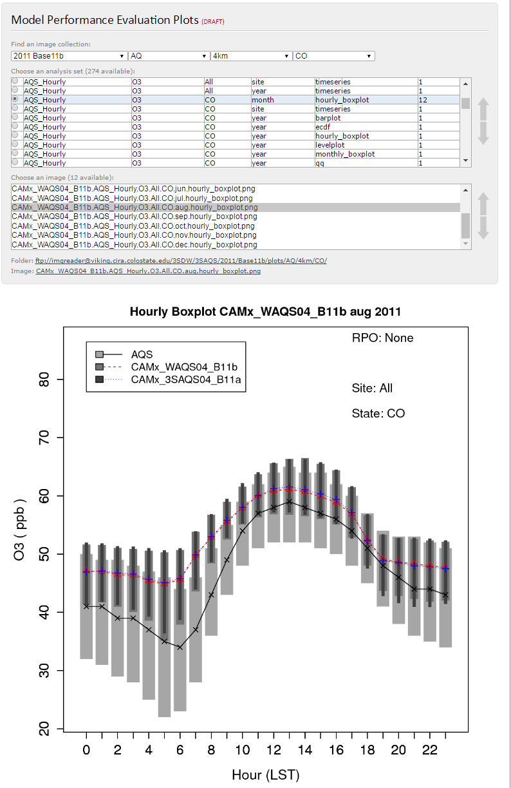

**Figure 2.4.** An example of the MPE Plots Tool display for the analysis set: 2011b modeling platform->AQ modeling results->4km modeling domain->State of Colorado. The selected image compares hourly ozone for August 2011 averaged across all AQS sites in Colorado to corresponding outputs from 2011b and 2011a modeling scenarios, respectively.

See development notes, Section A.3.

[Model-to-Observation Tool (Model-to-Obs)](http://localhost/TSDWAPP/Modeling/ModelObsComparison_IWDW.aspx): The Model-to-Obs Tool makes use of the same underlying data as the MPE Plots Tool, however the Tool relies on a database to generate dynamic plots, rather than static plots provided by the MPE Plots Tool. The IWDW Phase I version of the tool displays time series comparisons of model and observational data averaged to the sampling frequency of the observations. Comparisons are for individual monitoring sites or for network averages. The time series charts can be filtered by date range enabling users to focus on episodes of interest within a particular modeling year. The current tool does not provide comparisons of meteorological data.

**Table 2.4** is a summary of data available in the Model-to-Obs. The IWDW Phase I version includes 133,018,356 model output values, and 97,389,932 model-to-obs parings for 67 unique chemical parameters x metrics). The Tool includes 3SAQS 2008b 12km CAMx and WAQS 2011b 12km and 4km CAMx model output.

|  |  |  |
| --- | --- | --- |
| **Modeling Scenario and Monitoring Network** | **Metrics** | **Number of Records** |
| **2008b** | **61** | **16717468** |
| AQS | 8 | 14083770 |
| CASTNET | 11 | 246171 |
| CSN | 13 | 56775 |
| IMPROVE | 15 | 174872 |
| NADP | 6 | 18624 |
| NAPS | 8 | 2137256 |
| **2011b** | **99** | **80672464** |
| AMON | 1 | 668 |
| AQS | 13 | 79629774 |
| CASTNET | 19 | 405575 |
| CDPHE | 19 | 7752 |
| CSN | 16 | 68112 |
| IMPROVE | 17 | 288558 |
| NADP | 7 | 41972 |
| UGWOS | 2 | 5084 |
| UINTAH | 3 | 49889 |
| WYDEQ | 2 | 175080 |
| **Grand Total** |  | **97389932** |

**Table 2.4.** Number of metrics and records (e.g. model-to-obs pairings) in the Model-to-Obs tool by modeling platform and monitoring network.

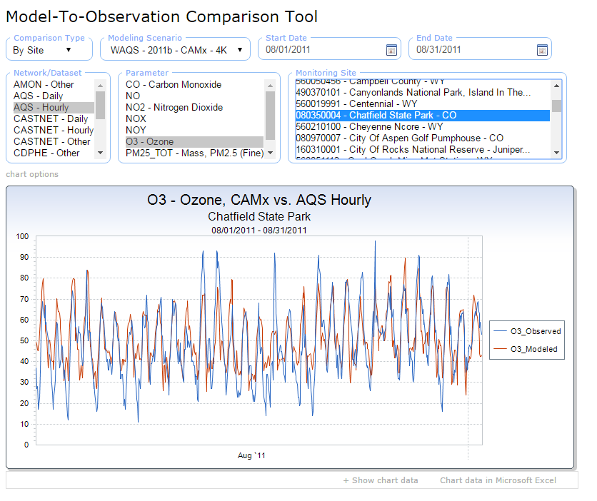

**Figure 2.5.** Example of the IWDW Model-to-Obs. display showing hourly AQS ozone compared to CAMx 4km model results at Chatfield State Park, CO.

[Source Apportionment (SA) Tools:](http://localhost/TSDWAPP/Data/SourceApportionment.aspx) Visualization tools and other data products for PM and ozone source apportionment. The visualization tools display dynamic charts that illustrate geographic and source category contributions to PM and ozone at AQS and CASTNet monitoring sites. 2011 Tools SA results across a virtual western U.S. receptor grid inside the 12km modeling domain.

IWDW Phase I deliverables were provided by UNC- IE and Ramboll-ENVIRON are listed in **Table 2.5**. Details on the modeling approach are available on the WAQS [SA Wiki](http://vibe.cira.colostate.edu/wiki/wiki/9128/waqs-phase-ii-source-apportionment-modeling). An entry point to the SA visualization tools and data produces is available on the IWDW website [SA data page](http://views.cira.colostate.edu/tsdw/Data/SourceApportionment.aspx).

|  |  |  |  |
| --- | --- | --- | --- |
| Study | Base Modeling Year | Modeling Scenario(s) | Data products |
| 3SAQS | 2008 | 2008b Base | SA Visualization Tool |
| 3SAQS | 2011 | 2011a Base (Round 1) | SA Visualization Tool; Interactive Spreadsheets; csv data files |
| WAQS | 2011 | 2011b Base (Round 2) | SA Visualization Tool; csv data files |
| WAQS | 2011 | 2011b Base “Clean” Simulation (Round 3) | Spatial maps showing modeled O3 and PM2.5 background concentrations |
| SNMOS | 2011 |  |  |
| Denver/N. Front Range | 2011 | 2017 Ozone SIP | Local Source Analysis Visualization Tool |
| Denver/N. Front Range | 2011 | 2017 Ozone SIP - | Transport Analysis Visualization Tool |

**Table 2.5.** SA modeling products available on the IWDW at the close of IWDW Phase 1.

* + 1. *Monitoring Data Tools*

The Tools in this section are leveraged from FED (see Dependencies, Section 2.d).The Monitoring Data Tools provide custom charts that summarize key metrics and/or trends in ambient monitoring data. The data products available from the respective Summary Tools are listed in **Table 2.6**.

|  |  |  |
| --- | --- | --- |
| Tool | Metric | Dataset |
| Visibility | Deciview – RHR best and worst 20% days; NC targets; ambient trends | IMPORVE |
| Ozone | 76ppb NAAQS, 4th highest 8-hr O3 concentration;  Ambient trend | AQS |
| Wet Deposition | Wet nitrate and ammonium ion in precip.; wet nitrate and ammonium deposition; Wet sulfate in precip.; wet sulfate deposition. Includes annual mass concentration timelines and trends, annual and cumulative deposition bar charts. | NADP - NTN |
| Dry Deposition | Dry HNO3, NH4+; NO3; SO4; SO2. Includes annual mass concentration timelines and trends, annual and cumulative deposition bar charts. | CASTNet |

**Table 2.6.** Monitoring Data Tools available on the IWDW at the close of IWDW Phase 1.

See development notes, Section A.3.

* + 1. *Metadata Tools*

The Tools in this section are leveraged from FED (see Dependencies, Section 2.d). **T**he [Monitoring Site Browser](http://localhost/TSDWAPP/SiteBrowser/Default.aspx) shows locations and site information for the monitoring sites in the integrated FED database. The tool includes metadata for monitoring sites from the standard monitoring networks (AQS, CASTNet, IMPROVE, NASP) that are routinely used for model validation and to calculate design values. Metadata include monitoring site details, a list of chemical species monitored at the site, and gross data statistics. Raw monitoring data can be downloaded, and summary charts that span the duration of available data can be generated.

Notes:

-show sites with no data in different label color (I can’t find an ARS O3 site with data)

-as with query wizard, filtering to Project relevant networks, and adding project studies would be useful

* 1. Resources: The [Resources](http://localhost/TSDWAPP/data/) landing page contains entry points to IWDW resources such as documentation and project management tools and materials.
     1. *Modeling Data*

The Modeling Data section of the Resources landing page provides links to resources that describe air quality modeling platforms included in the IWDW.

The [Modeling Studies](http://views.cira.colostate.edu/tsdw/Studies/) page provides a high level listing of all modeling studies hosted and/or archived in the IWDW. Modeling studies included in the IWDW are listed by the study name, or in some cases the entity that sponsored or conducted the modeling study. The Page includes IWDW-WAQS *Project Studies* (modeling studies sponsored by the IWDW-WAQS Project) and *External Studies* (modeling conducted by groups that are external to the IWDW-WAQS Project). **Table A.**2 lists the modeling studies in the IWDW, with the associated modeling platform, modeling scenario and links to documentation.

*Project Study* data are available via the IWDW Data Request page, and are supported by IWDW Analysis Tools. PSAT output for the RAQC and SNMOS Studies are available through visualization Tools provided by Ramboll-Environ. Other *External* study data are stored in IWDW archives.

Future plans: Data sharing arrangements are underway for the addition of Utah ARMS, OKT and CARMMS 2.0 modeling studies to the IWDW.

The [Modeling Platform Browser](http://views.cira.colostate.edu/TSDW/DataRequest/PlatformBrowser.aspx) provides general use recommendations authored by WAQS Cooperators and details about WAQS modeling platforms. The each modeling platform is broken into the following content sections:

1. Modeling Software

2. Emissions Data

3. Meteorology Data

4. Initial and Boundary Conditions

5. Other Input Data

6. Model Performance

7. Output Data

The respective content sections are expandable, allowing users to browse individual modeling platform components. Users can browse file level contents of each modeling platform component on the IWDW ftp directory. The Modeling Platform Browser is a “stripped down” version of the modeling platform selection UI on the Data Request page. As with the Data Request Page, The Modeling Platform Browser displays the 3SAQS 2008b and 2011a platforms, and WAQS 2011b modeling platform. The content source for the respective UIs on each tool are modeling platform specific xml files that provide metadata and platform file locations on the ftp file server (see [IWDW Status wiki](http://vibe.cira.colostate.edu/wiki/wiki/9133/iwdw-phase-i-status)).

Future: The WAQS 2014 platform will be added to the Modeling Platform Browser. Support for modeling studies conducted by groups outside the IWDW-WAQS Project will be determined by the Project Cooperators.

* + 1. *Reference Documentation*

This section of the Resources landing page provides links to references documents and other content describing the IWDW-WAQS Project. The Data Documents page focus on WAQS emissions and air quality modeling activities, while the Project Documents page contains materials that document Project organization. Additional documentation related WAQS modeling and IWDW operations is available on the IWDW-WAQS Wiki (see *Community and Support*, below).

The IWDW [Data Documents](http://localhost/TSDWAPP/Documents) page contains links to 3SAQS/WAQS emissions and air quality modeling protocols, model performance evaluation documents and associated response to comments documents, technical reports, monitoring network assessments, and related documentation for the IWDW-WAQS data. At the close of IWDW Phase 1 the Data Documents page contained 44 documents related to emissions and modeling studies. **Table 2.7** is an inventory of documents on the IWDW Studies page.

|  |  |  |  |
| --- | --- | --- | --- |
| Study | Description | N |  |
| 3SAQS | Emissions | 3 |  |
| 3SAQS | Modeling | 9 |  |
| 3SAQS | Network | 2 |  |
| EPA | Emissions | 1 |  |
| RAQC | Modeling | 2 |  |
| WAQS | Emissions | 9 |  |
| WAQS | Modeling | 16 |  |
| WAQS | Work Plans | 2 |  |

**Table 2.7.** Documents contained on the IWDW Data Documents page listed by Study/entity. EPA documents link to files on EPA websites.

The [Project Documents](http://views.cira.colostate.edu/tsdw/Resources/project_documents/ProjectDocuments.aspx) Page includes Project level documents, such as outreach materials, status reports, organizing documents, work plans, network assessments, and Project MOUs. Access to the Project Documents page is restricted to IWDW-WAQS Technical Committee members.

See development notes, A.3., sec. 2.3.2.

The [Literature](http://views.cira.colostate.edu/tsdw/Literature/Default.aspx) page provides a list of publications relevant to emissions inventories and air quality studies in the Intermountain West.

Notes:

Merge literature page with OGEC Repository literature sections. Latter is more up to date.

* + 1. *Community and Support*

This section of the Resources landing page provides numerous resources to Project Cooperators and general IWDW users, including:

The IWDW [Forum](http://localhost/TSDWAPP/Forum/Default.aspx) hosts user groups primarily focused on IWDW website issues, the WAQS document review process, and general questions about WAQS modeling platforms.

The IWDW-WAQS [Wiki](http://vibe.cira.colostate.edu/wiki)  contains documentation on WAQS modeling activities and IWDW operations. The WAQS wiki includes details on modeling activities, such as sensitivity analyses and source apportionment modeling, that augment Project sponsored modeling.

The [Updates](http://localhost/TSDWAPP/Data/Updates.aspx) page shows a chronological list of content addition to the IWDW website, Wiki, and modeling and monitoring data stored in the data warehouse.

The [Site Index](http://views.cira.colostate.edu/tsdw/Resources/SiteIndex.aspx) is a flat list of all pages on the IWDW website and IWDW-WAQS Wiki.

The [Meetings](http://localhost/TSDWAPP/Meetings/Default.aspx) page lists Project meetings and provides links to agendas, minutes and other materials. The Meetings page is the main point of coordination for the IWDW-WAQS Technical Committee.

The [How-To](http://views.cira.colostate.edu/tsdw/Resources/HowTo.aspx) page describes how IWDW-WAQS modeling platforms are organized, their potential application to IWDW user initiated modeling studies, how to request modeling platform data from the IWDW, and how to use IWDW resources to download and explore air quality monitoring data and WAQS modeling platforms.

See development notes, Section A.3.

* + 1. *Warehouse Operations and Management*

This section of the Resources landing page provides resources for IWDW-WAQS project management.

The [Data Request Overview](http://localhost/TSDWAPP/DataRequest/DataRequestOverview.aspx) page lists user’s data requests that have been submitted to the IWDW. The page tracks the status of individual data requests through their life cycle in the IWDW inventory tracking system. The page is used by the IWDW Project Stewards group to review data requests and is a key part of the IWDW inventory tracking system. Access to the page is restricted to Project Stewards and Administrator groups.

The [Projects Overview](http://localhost/TSDWAPP/Project/ProjectsOverview.aspx) page is designed to help IWDW users track the status of their data requests in the IWDW. Once a data request is authorized, an IWDW Project is created and the initial data request, and all subsequent requests related to the Project, are added to the IWDW Project. This allows managers, for example the sponsoring agency contact, to easily view the status of all data requests related to their project. Users must be logged in to view this page, and only those assigned to the Project *Team* can edit Project information.

The [Governing Board and Oversight Committee](http://views.cira.colostate.edu/TSDW/Oversight/Default.aspx) page lists meetings and related documents for the IWDW-WAQS Governing Board and Oversight Committee. Access is restricted to IWDW-WAQS Governing Board and Oversight Committee Members.

User Management: The IWDW website includes pages for users to create and manage their own user account, and to sign into the site. There are currently 195 user accounts registered on the IWDW website. A list of all IWDW user accounts as of 9/28/16 is provided on the IWDW Status wiki.

Administration:A suite of administrative pages allow site administrators to manage user accounts, such as adding users to various groups thereby providing certain users access to restricted web content. Other administrative pages allow site administrators to manage the *data category and file system structure* used by the data request user interface.

1. **Operations**

This section provides an in depth summary of IWDW operations, such as incoming and outgoing transfers of modeling platform data, data processing, meetings and other operational management activities conducted during IWDW Phase 1.

* 1. Data transfers

Ambient monitoring data: Ambient monitoring data are uploaded periodically from data providers to the source databases that provide data for IWDW monitoring data tools. These operations are leveraged by the IWDW from the FED Project at CIRA. Data transfers to FED and downloads by users are not tracked explicitly.

Incoming modeling data transfers: The Modeling Studies Table (**Table A.2.1**) lists modeling platform data transferred from WAQS AQ modeling contractors to the IWDW. *Project* data for 3SAQS and WAQS modeling platforms were transferred from either UNC or Ramboll-Environ, depending on which group conducted various modeling scenarios. *External* modeling study data for WestJumpAQMS were adopted from WESTAR/WRAP. *External* modeling study data for CARMMS 1.0, RAQC and SNMOS were transferred from Ramboll-Environ, the AQ modeling contractor for those studies.

Outgoing modeling data transfers: **Table A.3** lists 31 data request that moved past the Submitted phase. Of these, 26 resulted in data released by the IWDW to users. Data were delivered either by providing users ftp access to the IWDW file server, or by shipping physical disk drives to users. The IWDW provided modeling platforms for five NEPA AQ modeling studies and two SIP modeling studies. Approximately 320 Tb of modeling data, across nearly one million files, were released during IWDW Phase 1.

* 1. Data processing

Various post-processing steps need to be applied to the data provided to the IWDW before these data can support IWDW tools.

MPE Plots: Graphics that support the MPE Plots too are generated by a collection of “R” scripts encapsulated by the AMET software package (see IWDW Procedures).

The Emissions Review Tool uses custom SMOKE reports to generate output tailored for the database tool’s source database. For example, the custom report applies chemical speciation profiles and county totals, although does not apply temporal profiles. Data are then rolled up source category and parameter groups (see IWDW Status wiki).

* 1. Project management

Meetings and workgroups conducted by the IWDW Team include: IWDW-WAQS Technical Committee; IWDW Operations; IWDW-WAQS Project Stewards; and the IWDW Tools Workgroup. **Table 3.1** lists the various committee and workgroup meeting conducted during IWDW Phase 1. Links to up-to-date meeting materials are included in the Table.

|  |  |  |  |
| --- | --- | --- | --- |
| Group | Number of meetings | Agenda & Minutes | Date range |
| Governing Board |  | [Minutes](http://views.cira.colostate.edu/TSDW/Oversight/Default.aspx) |  |
| Oversight Committee |  | [Minutes](http://views.cira.colostate.edu/TSDW/Oversight/Default.aspx) |  |
| Technical Committee | 16 | [Minutes](http://views.cira.colostate.edu/TSDW/Meetings/Default.aspx) | 5/2013-8/2016 |
| Project Stewards | 10 | [Minutes](http://vibe.cira.colostate.edu/wiki/wiki/5096/iwdw-waqs-project-stewads) | 6/2015-10/2016 |
| Tools Workgroup | 6 | [Minutes](http://vibe.cira.colostate.edu/wiki/wiki/5098/iwdw-tools-workgroup) | 9/2015-3/2016 |
| IWDW Operations | 36 | [Minutes](http://vibe.cira.colostate.edu/wiki/wiki/5095/) | 12/2014-9/2016 |
| Modeling Group |  |  |  |

**Table 3.1.** IWDW-WAQS Committee and Workgroup meeting conducted during IWDW Phase 1.

Major outcomes include:

* Governing Board and Oversight Committee: See meeting materials for minutes and outcomes.
* Technical Committee: Release of 2011a and 2011b modeling platforms; Release of MPE Guidance Document; Release of NEPA Guidance Document; various recommendations on WAQS modeling protocols.
* Project Stewards: Approval of IWDW-WAQS Data Use Agreement; Review and assignment of Steward to IWDW Data Requests.
* Tools Workgroup: Provide input and feedback to IWDW Development Team on web based tool design; Provide input on alignment of IWDW tools and data products with MPE Guidance Document.
* Modeling Group: Modeling protocol documents, simulations, model performance and application documents for meteorological, emissions, and air quality modeling for 3SAQS 2008b and 2011a platforms, and WAQS 2011b platforms. Meteorological modeling for WAQS 2014 platform. Various model sensitivity analyses (see [WAQS wiki](http://vibe.cira.colostate.edu/wiki#WAQS))
* IWDW Team: Website and tool development; interact with WAQS modeling groups on modeling platform transfers; modeling data post-processing; handle data requests; IT issues.

See development notes, Section A.3.

* 1. Dependencies

The IWDW leverages computer hardware and software from other data warehouse projects at CIRA, and also leverages the work of modeling groups external to the WAQS.

Database infrastructure, computer hardware and software, developed for the Federal Land Manager Environmental Database ([FED](http://views.cira.colostate.edu/fed/)) project. Some web-based tools from FED are included on the IWDW website, such as the database query wizard, monitoring site browser, visibility and ozone AQRV summary Tools. The IWDW website adds wet and dry deposition AQRV summaries that are not included on the FED website, however share code and backend database developed for FED.

The IWDW provides data archive and various degrees of hosting and analysis products for External modeling studies conducted by groups that are not sponsored by the IWDW-WAQS Project. **Table A.2.2** lists of External modeling studies currently hosted and/or archived by the IWDW.

1. **Computer Hardware, Code Base, and Data Storage**
   1. Computer infrastructure: **Table 4.1** lists IWDW computers used for the IWDW FTP server, web site, databases and backup file system.
   2. Code base: **Table 4.2** provides an overview of the IWDW code base. Everything in our Git repository, including the EDMF, XP, and TSDW solutions at a minimum. Database code base: SQL scripts, stored procedures, DDL, etc. I’m not sure that these are in Git – would have to check with Dustin. Also, there’s a large contingent of these that are not part of a specific database (i.e. that wouldn’t be covered by a database backup). Wiki: Hosted on VIBE; Depends upon a database, probably VIBE.wiki – need to confirm with Dustin
   3. Documents: The main directories containing Project documents are listed below:

* Data Documents: \\VIEWS\inetpub\wwwroot\documents\Projects\TSDW
* Project Documents: \\VIEWS\inetpub\wwwroot\tsdw\resources\project_documents\
* Oversight and Governing Board: \\VIEWS\inetpub\wwwroot\tsdw\Oversight\Files\
* Wiki documents, images, etc.: \\Vibe\wiki\App_Data\Attachments\
  1. Databases: Key database that support the IWDW website and tool are listed below:
* VADER.AIRDATA_CORE
* VADER.AIRDATA_IMPORT
* VADER.AIRDATA_EMISSIONS
* VADER.WARD_FORUM
* VIBE.AIRDATA_MEMBERSHIP
* VIBE.IWDW_ModelToObs
* Others to support development, prototype applications, and intermittent database backups

|  |  |  |  |  |
| --- | --- | --- | --- | --- |
| Computer | Function | Total file size | Operating System | Application |
| Viking | FTP file server |  | Linux |  |
| Views | Web server |  | Windows |  |
| Vader | Database server – production |  | Windows |  |
| Vibe | Wiki and database server |  | Windows |  |
| Vidi | Database server - staging |  | Windows |  |
| EDMF NAS | Backup |  | Linux |  |

**Table 4.1.** IWDW Computer infrastructure

|  |  |  |  |
| --- | --- | --- | --- |
| Application | Code base | Role | Location |
| TSDW Solution | AirData.Core | Data transformation and SQL queries | GIT repository on Vibe; Production on Views; IWDW Team development machines |
| EDMF.WEB.UI.WebControls | Chart controls |
| EDMF APP | User management, tools leveraged from FED |
| TSDW APP | TSDW website code |
| XP |  |
| Wiki | Roadkill | IWDW-WAQS Wiki | Vibe/Views |
| Forum | YAF Forum |  | Vibe/Views |

**Table 4.2.** IWDW code base

1. **Preliminary work plan for IWDW Phase 2**
   1. Un-deployed resources and “loose ends” from IWDW Phase 1

* Update Data Request Procedure wiki to reflect current Data Request UI.
* Sync Data request UI with NEPA process document.
* Edit ERT Map parameter label to “VOC (includes TOG from MOVES)”.
* MAP ERT totals in pie – why not make these reflect colored regions on map (having a separate blue outline is confusing).
* Bugs in map ERT image download – error on map download.
* Map and Chart ERT QA – make sure total etc., match.
* MPE Plot Archive [pending]: Points to ftp directories with static plots organize by relevance to various MPE grouping. Plots generated by Project Cooperators can be uploaded to the IWDW and made available to IWDW users through the archive.
* Model Performance Evaluation Metrics (MPE Metrics): Prototype tool to display tabular results from PGM MPE. Various metrics (such as NME, NMB, correlation coefficient, etc.) derived from comparisons of PGM results to observations, can be selected and displayed in tabular format. The tool was developed in Phase 1, although not deployed. The tool could be used as an alternative selection UI for the MPE plots tool with additional development.
* Others (see Development Notes, Section A.3).
  1. Software Development Goals
     1. Incorporate emissions comparisons between WAQS emissions scenarios to user developed planning scenarios. Allow users to upload emissions from their own modeling studies in future tool versions.
     2. Provide VOC speciation data, where available, in emissions tools (e.g. in model ready emissions inputs or at other preliminary processing stage after speciation profiles have been applied).
     3. Expand GIS capabilities to display gridded model ready emissions and AQ model output using binaries as source data.
     4. Develop in-hose AMET ‘type’ processing of model output (emissions, meteorology, AQ modeling results), possibly incorporating web based R scripting and display.
  2. Integration with WAQS Phase 3 Modeling
     1. Develop specific guidelines for model output regarding output parameters and file formats.
  3. Incorporate external modeling studies
  4. Other outcomes (track publications using IWDW supported modeling platforms)
  5. Monitoring Network Assessment

Appendix

**A.1** Modeling Studies

|  |  |  |  |  |  |
| --- | --- | --- | --- | --- | --- |
| **Study** | **Modeling Platform1** | **Modeling Scenario2** | **Documents3** | **IWDW Release Date** | **Status** |
| **3SAQS** | [**2008b**](http://views.cira.colostate.edu/tsdw/DataRequest/PlatformBrowser.aspx?Platform=3SAQS%2008b) | * [**2008b**](http://vibe.cira.colostate.edu/wiki/wiki/1026/3saqs-2008b-modeling-platform) * [**WRF 2008**](http://vibe.cira.colostate.edu/wiki/wiki/1027/wrf-2008) * [**SMOKE 2008b**](http://vibe.cira.colostate.edu/wiki/wiki/1032/smoke-2008b) * [**CAMx 2008b**](http://vibe.cira.colostate.edu/wiki/wiki/1031/camx-base-2008b) * [**CAMx 2020a**](http://vibe.cira.colostate.edu/wiki/wiki/1039/camx-2020-2008-based-projection-simulation) | * [**2008 Emissions and Air Quality Final Modeling Protocol**](http://views.cira.colostate.edu/tsdw/documents/?file=3SAQS_2008_Modeling_Protocol_Final.pdf) * [**2008b CAMx Final MPE**](http://views.cira.colostate.edu/tsdw/documents/?file=3SAQS_Base08b_MPE_Final_30Sep2014.pdf) | 9/30/2014 | Available |
| **3SAQS** | [**2011a**](http://views.cira.colostate.edu/tsdw/DataRequest/PlatformBrowser.aspx?Platform=3SAQS%202011a) | * [**2011a**](http://vibe.cira.colostate.edu/wiki/wiki/1018/3saqs-2011a-modeling-platform) * [**WRF 2011a Meteorology**](http://vibe.cira.colostate.edu/wiki/wiki/1028/wrf-2011a-meteorology-results) * [**SMOKE 2011a Emissions**](http://vibe.cira.colostate.edu/wiki/wiki/1030/smoke-2011a-emissions-results) * [**CAMX 2011a Base Year Modeling Results**](http://vibe.cira.colostate.edu/wiki/wiki/1029/base2011a-modeling-results) * CAMx 2020a Future Year Modeling Results * [**CAMx 2011a USBG Sensitivity**](http://vibe.cira.colostate.edu/wiki/wiki/1020/background-air-quality-modeling-results) * [**CAMx 2011a BC Sensitivity**](http://vibe.cira.colostate.edu/wiki/wiki/1043/bc-sensitivity-modeling-results) * [**CAMx 2011a On-Road Mobile Sensitivity**](http://vibe.cira.colostate.edu/wiki/wiki/1067/moves2014-sensitivity-modeling-results) * [**Visibility/Haze Modeling**](http://vibe.cira.colostate.edu/wiki/wiki/1073) * [**MATS Modeling Results**](http://vibe.cira.colostate.edu/wiki/wiki/1069/mats-modeling-results) * [WAQS Phase II SA Modeling Wiki](http://vibe.cira.colostate.edu/wiki/wiki/9128/) Round 1 | * [**WRF 2011 Meteorological Model Application/Evaluation**](http://views.cira.colostate.edu/tsdw/documents/?file=3SAQS_2011_WRF_MPE_v05Mar2015.pdf) * [**WRF Meteorological Model Winter Modeling Work Plan**](http://views.cira.colostate.edu/tsdw/documents/?file=WSAQS_WRF_Winter_Modeling_Final.pdf) * [**2011 Emissions & Air Quality Modeling Protocol**](http://views.cira.colostate.edu/tsdw/documents/?file=3SAQS_2011_Modeling_Protocol_Finalv2.pdf) * [**2011 Final CAMx Model Performance Evaluation**](http://views.cira.colostate.edu/tsdw/documents/?file=3SAQS_Base11a_MPE_Final_18Jun2015.pdf) * [**Modeling Plan for Conducting Source Apportionment**](http://views.cira.colostate.edu/tsdw/documents/?file=WAQS_SA_Plan_2011_2015-09-02.pdf) | 4/30/2015 | Available |
| **WAQS** | [**2011b**](http://views.cira.colostate.edu/tsdw/DataRequest/PlatformBrowser.aspx?Platform=WAQS%202011b) | * [**2011b**](http://vibe.cira.colostate.edu/wiki/wiki/2077/3saqs-2011b-modeling-platform) * 2011b Winter Meteorology * [**SMOKE 2011b Base Year Emissions**](http://vibe.cira.colostate.edu/wiki/wiki/2078/smoke-2011b-emissions) * [**SMOKE Future Year (2025) Emissions**](http://vibe.cira.colostate.edu/wiki/wiki/7112/waqs-2011b-platform-future-year-emissions) * [**CAMx and CMAQ Base Year Modeling Results**](http://vibe.cira.colostate.edu/wiki/wiki/2084/base2011b-camx-and-cmaq-modeling-results) * CAMx Future Year Modeling Results * [WAQS Phase II SA Modeling Wiki](http://vibe.cira.colostate.edu/wiki/wiki/9128/) Rounds 2 & 3 | * [**2011 Emissions & Air Quality Modeling Protocol**](http://views.cira.colostate.edu/tsdw/documents/?file=3SAQS_2011_Modeling_Protocol_Finalv2.pdf) * [**2011b CAMx/CMAQ Draft Model Performance Evaluation**](http://views.cira.colostate.edu/tsdw/documents/?file=WAQS_Base11b_MPE_Draft_21Jan2016.doc) | 5/18/2016 | Available |
| **WAQS** | 2014 | * 2014 * WRF 2014 Meteorology | * [**WRF Modeling Protocol**](http://views.cira.colostate.edu/tsdw/documents/?file=WAQS_2014_WRF_Modeling_Protocol_Final_04Sep2015.pdf) * [**WRF Model Performance Evaluation**](http://views.cira.colostate.edu/tsdw/documents/?file=WAQS_2014_WRF_MPE_January2016.pdf) | TBD | Under development |

**Table A.1.1.** IWDW-WAQS Project sponsored modeling studies.

1 Link to IWDW Modeling Platform Description (and file browser) page for the respective modeling platform.

2 Links to IWDW Wiki entries for the respective modeling scenario.

3 Link to the IWDW Data Documents page and documents related to the modeling platform.

|  |  |  |  |  |  |
| --- | --- | --- | --- | --- | --- |
| **Study** | **Modeling Platform1** | **Modeling Scenario2** | **Documents3** | **IWDW Release Date** | **Status** |
| **WestJump AQMS** | 2008c | * WRF 2008 | * Background on the [WRAP Regional Technical Center and WestJumpAQMS](http://www.wrapair2.org/WestJumpAQMS.aspx) web page | 9/30/2014 | Archive |
| **CARMMS** | 1.0 | * 2008 Base * 2021 Future | * Background on the [BLM CARMMS web](http://www.blm.gov/co/st/en/BLM_Information/nepa/air_quality/carmms.html) page. The Study included development scenarios for low, medium and high emissions projections. | TBD | Archive |
| **RAQC** | 2011b | * CAMx 2011b Base * CAMx 2017 Future | * Background on the [**Denver RAQC SIP**](http://raqc.org/our_programs/state_implementation_plans/) web page * [IWDW Denver/NFR Wiki](http://vibe.cira.colostate.edu/wiki/wiki/9132) | 9/19/2016 | Available (SA visualization tools) |
| **SNMOS** | 2011b | * CAMx 2011b Base * CAMx 2025 Future | * Background on [WRAP SNMOS webpage](http://www.wrapair2.org/SNMOS.aspx) * [IWDW SNMOS WIki](http://vibe.cira.colostate.edu/wiki/wiki/9131/) | 9/19/2016 | Available (SA visualization tools) |

**Table A.1.2.** IWDW-WAQS External modeling studies.

1 Link to IWDW Modeling Platform Description (and file browser) page for the respective modeling platform.

2 Links to IWDW Wiki entries for the respective modeling scenario.

3 Link to the IWDW Data Documents page and documents related to the modeling platform.

**A.2** Data Requests Released from the IWDW



**Table A.2.** IWDW-WAQS modeling platform data requests released from the IWDW. The table reflects the contents of the IWDW [Data Request Overview](http://views.cira.colostate.edu/tsdw/DataRequest/DataRequestOverview.aspx) page at the close of IWDW Phase 1.

**A.3 Development Notes**

2.2.1 Query Wizard

* For IWDW version of QW add special studies and Project sponsored sites (UGRS, etc.)
* Filter to include only datasets with data during modeling time period (e.g. remove some special studies like MOHAVE, SEAVS, SEARCH , REVAL, SFU…)
* why list metrics with dataset (e.g. NADP NTN precip weighted means (ueq/L) and mg/L?

2.2.2 Emissions data tools

* change “Source Category” label to “Source Category Groups” (Sector-> source category groups in mapping tool)
* add source category group mapping descriptions
* ✓edit to Scenario labels so they are consistent with “studies” nomenclature
* remove 2018-11 label from Scenario (or add 2011a future case data if available)
* ✓relabel parameter “VOC (MOVES TOG)” to “VOC (Includes MOVES TOG)”
* add to errata: explain why we lump MOVES TOG into VOC parameter (e.g. why not make MOVES TOG an emissions group mapped to VOC with a similar caveat?)
* Fix capitalization in chart titles (looks like code is forcing titles to sentence case)
* add functionality for multiple platform/scenario selection (or only allow single scenario selection so Tool does not throw an error when multiple scenarios are selected)
* It would be interesting to compare ERT mappings to those for premerged and model ready inputs
* add NEI emissions that were used to create respective WAQS base cases
* add ability to swap parameter/sector (allow looking at all parameters within a sector vs just all sectors within a parameter group)
* no biogenics in 2011b emissions
* biogenics in 2008b, 2011a, but biogenic CH4=0 (included in VOCs?)
* 2011b Base include EGroupID=40 (ptncem), which is not in 2011b Future. Looking at Tool, point source totals are much higher in Base Case.
* 2011b inventories include 5 source categories that do not report at the SCC level (Ag fires, wild fires, prescribed burning, windblown dust, MOVES Onroad Mobile)
* Should document mappings for StCnty/StateCntySCC Egroups to UI source category groups
* State and StateCnty EGroup totals match
* why is ERT mapping tool password protected?

2.2.3 Modeling data tools

MPE Plots:

* Base25a_11b plots not showing up in UI or ftp
* Future work:
  + provide an index which allows searching for plots by keywords
  + UI to highlight plots that are designated in the MPE Checklist
  + provide a map based UI to select plots
  + provide .csv files for all plots

Model-to-obs:

* current network select box allows multiple selection, although only shows results from first selection.
* could use a description of network, e.g. NAPS, and State sponsored and/or special studies
* add 2011b CMAQ results
* changing parameter selection reloads site selection making it difficult to compare parameters at a single site.
* move metrics/aggregations to parameter list (eg add AQS hourly to O3_hourly in parameter) or add aggregation select box. This would also allow removal of “hourly, daily, other” from network labels. The aggregation interval is already on the chart title, so it is not really necessary on the select box
* don’t need to spell out parameter names in parameter select box. These are on the chart title.
* migrate exceedances, 4th highest, etc. metrics from monitoring reports (tool becomes like SA vis tools)

2.2.4 Monitoring data tools

Visibility Summary:

* is it relevant or even clear to have “IMPROVE Aerosol RHR, New Equation” as metric. Can we/should we add EPA RHR calculation? Is this a priority for the IWDW, or other FED Projects?

Ozone Summary:

* Longs Peak chart title is Long’S peak. (look for other typos)
* might be nice to have a NAAQS exceedance map overlay, and/or show number of exceedances in map labels
* Revise to 2015 primary and secondary 70ppb standard
* Add W126 index

Wet Deposition:

* nitrate in precip. plot is not scaled to data; i.e. Niwot Saddle; RMNP Beaver Meadows

Wet & Dry Deposition:

* do tabs that say “Composition” mean to say “Deposition”?

2.3.2 Documentation

* move work plans an network assessment docs from data documents to project documents

2.3.3 Community and Support

* Add links to Meetings, How-To, main About pages to Resources landing page
* Update site index

3.3 Project Management

* Move TC/GB from meetings page to OC/GB page, remove GB/OC on meetings page, update TC

1. Refer to [WESTAR NPS Cooperative Agreement](http://www.westar.org/Docs/Quarterly%20Reports/WESTAR%202016%20Q1.pdf), 3SAQS Task 2 & IWDW-WAQS Task 3.